horizontal line

**Delhi Technological University**

Department of Applied Physics

IVth Semester

**MICROPROCESSORS & INTERFACING**

**MPI EP - 206**

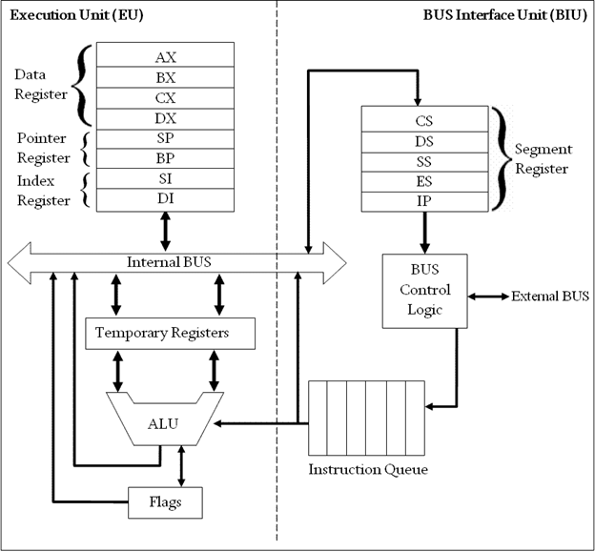

# **Submitted by :**

**ADITYA SINGH, 2K19/EP/005**

**Submitted to:**

**Dr. Rishu Chaujar**

# **Experiment 5**

**Generate an Arithmetic Progression (AP) Series**

**THEORY**

1. org 100h is used to set IP to 100h
2. Store 2000h memory location to the SI register
3. Store the value of the first term of AP in AL, common difference in DL and number of terms in CX register.
4. Point SI to 2010h memory location.
5. Add the contents of AL and DL register and store it in AL register to get the next term of the series.
6. Display the terms by moving the contents of AL to the memory location pointed by the SI register.
7. Increment SI after every iteration to make it point to the next memory location.
8. Repeat steps 5-8 until CX=0

**CODE**

**org 100h**

**mov si, 2000h**

**mov al, [si]**

**mov dl, [si+1]**

**mov cx, [si+2]**

**mov si, 2010h**

**ap:**

**mov [si],al**

**add al,dl**

**inc si**

**loop ap**

**hlt**

**OUTPUT**

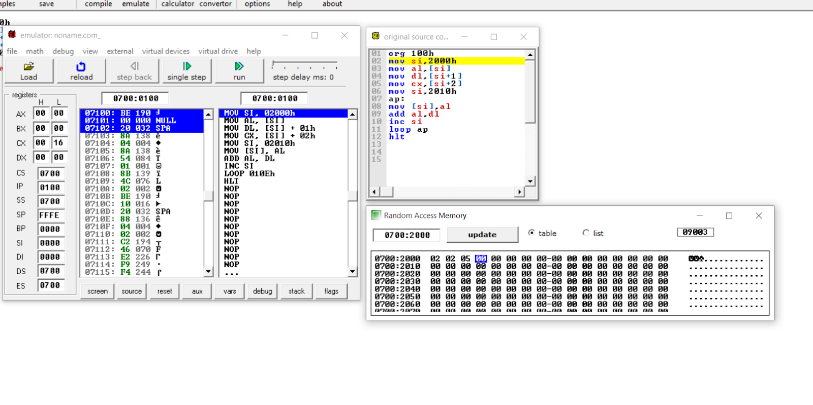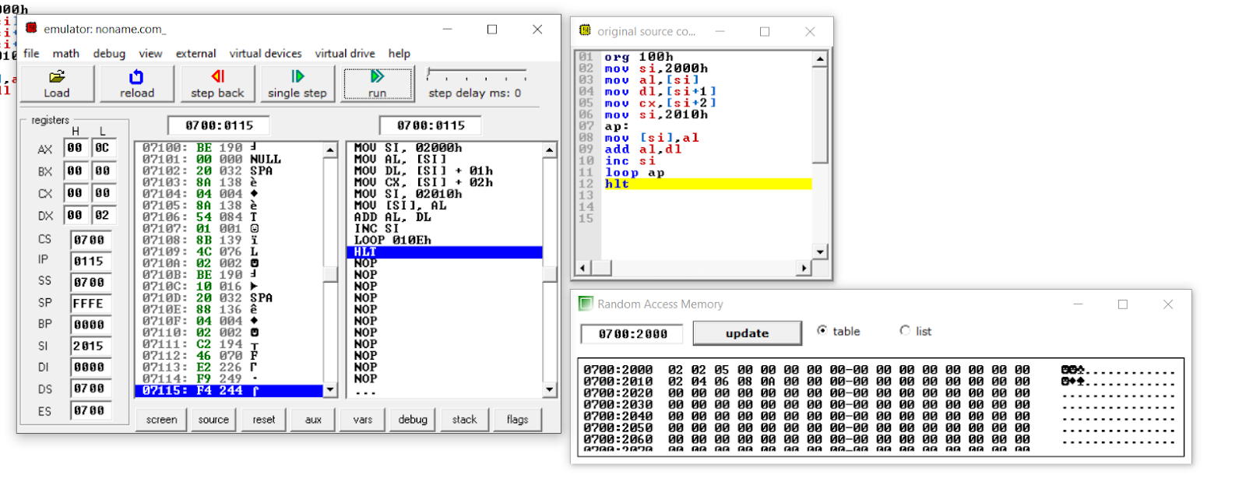

**END**